**Public Quarterly Report**

**Date of Report:** 9th Quarterly Report, April 1, 2025

**Contract Number:** 693JK32210009POTA

**Prepared for:** Government Agency: DOT and Co-funders

**Project Title:** Innovative Leak Detection Methods for Gas and Liquid Pipelines

**Prepared by:** Pipeline Research Council International, Inc.

**Contact Information:**Gary Choquette: gchoquette@prci.org phone: 402-917-3395

**For quarterly period ending:** March 30, 2024

**1: Items Completed During this Quarterly Period:**

|  |  |  |  |  |  |  |  |
| --- | --- | --- | --- | --- | --- | --- | --- |
| ***Item #*** | ***Task #*** | ***Activity/Deliverable*** | ***Title*** | ***Federal Cost*** | ***Cost Share*** | | |
| 7 | 4 | PODS draft SCADA interface data model | Results to be included in quarterly report | $23,796 | | $23,796 |
| *27* | *1* | *Quarterly project management & status update* | *Submit 8th quarterly report* | *$2,232* | *$2,232* | | |

**2: Items Not Completed During this Quarterly Period:**

|  |  |  |  |  |  |
| --- | --- | --- | --- | --- | --- |
| ***Item #*** | ***Task #*** | ***Activity/Deliverable*** | ***Title*** | ***Federal Cost*** | ***Cost Share*** |
| *21* | *5* | *Quasi transient pack method documentation* | *Quasi transient pack method documentation* | *$18,780* | *$18,780* |
| *24* | *2* | *Pipeline simulated leak analytics w/ tuned and 'as found' system* | *Summary report of simulated leak results.* | *$11,579* | *$11,579* |
|  |  |  |  |  |  |
|  |  |  |  |  |  |

**3: Project Financial Tracking During this Quarterly Period:**

*Note that this chart reflects Federal share only.*

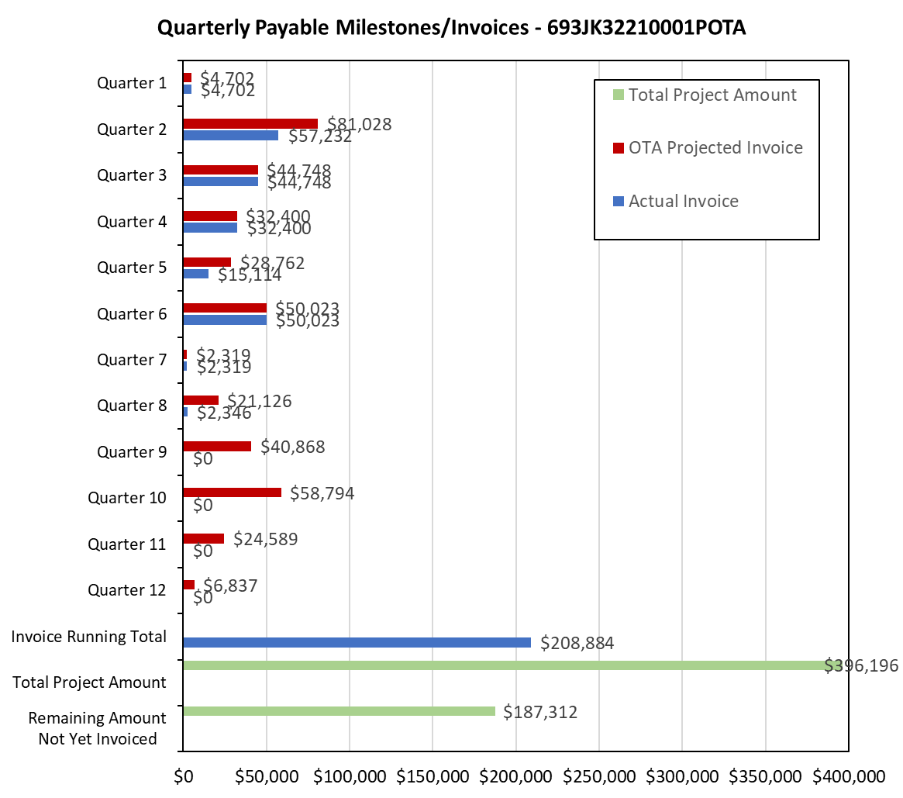

**4: Project Technical Status**

***Host Site Data***

Applied the inline meter calibration methodology to the host system which has five balance zones with four sets of bi-directional inline meters interconnecting them.

The inline meter calibration process first adjusts the imbalance of the combined system to zero by splitting the imbalance between the receipts and deliveries for a period of time.

* January 2022 was chosen as there appeared to be no imbalance changes for the period.
* There was one two-day period where a line pack error was present for two days, but no line pack error was detected at the start or end of the period.
* A single imbalance for the month was applied to each meter daily.
* Using this data and grouping the zones on either side of the inline meters, two balances were created for each set of inline meters. For example: to calibrate the inline meters between Zone A and B, balances for Zone A and the combined Zones B, C, D and E were done. To calibrate the inline meters between zone B and C, balances for the combined Zones A and B and the combined Zones C, D and E would be done. This pattern is repeated for all 4 sets of inline meters.
* The next step would have been to split the difference between each set of balances to come up with a meter calibration factor for each set of inline meters. However, the difference between the inline meter balances showed that the inline meters were already accurately calibrated.

Zone A compared to Zones B,C,D,E was 0.03%, Zones A,B compared to Zones C,D,E was 0.03%, Zone D compared to Zones A,B,C,E was 0.05% and Zone E compared to Zones A,B,C,D was -0.02%. As an example, the figure directly below shows the accumulated zone imbalance between Zones C and E:

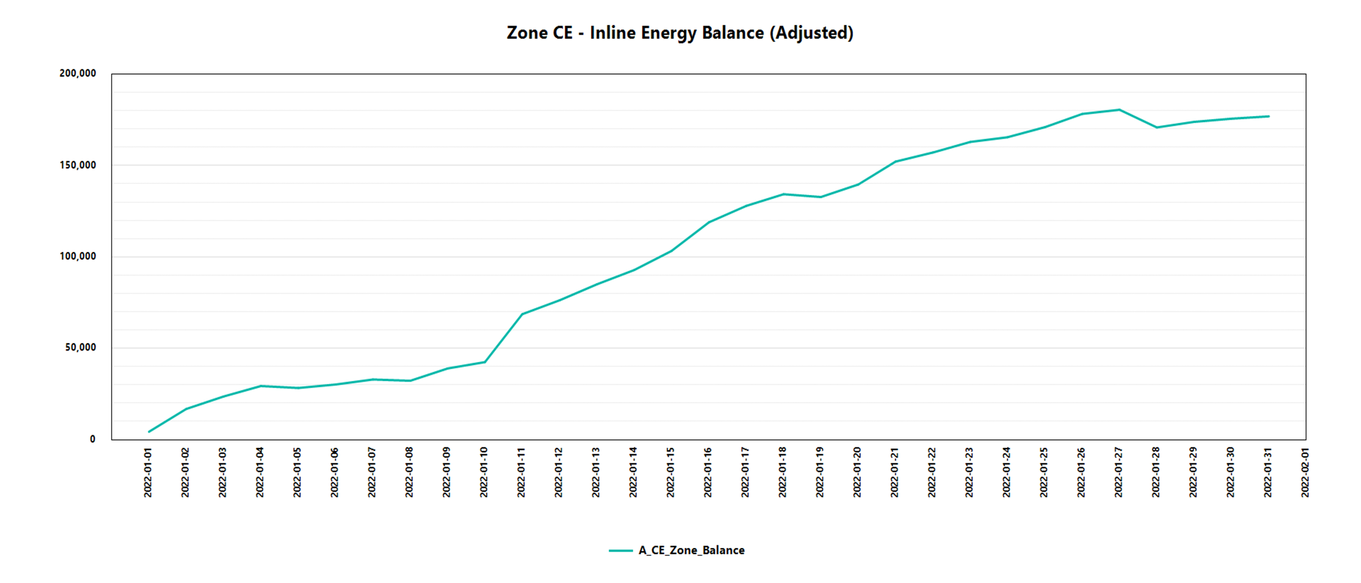

This is one of scores of analyses completed for the host data (it would overwhelm this report to include them all here but they will be included in the final report). The imbalance accumulation presented here represents an additional analytic method not anticipated upon the initialization of this project in that it identifies if an imbalance is steady over time or increasing/decreasing and therefore actively an issue with the case where is more entering a zone than leaving the zone an indication of a possible leak/loss/theft.

The analysis showed that the techniques and methods are suitable for assessing large datasets of real data. Although not part of this scope of work, the dataset will continue to be used for additional analytics and analysis. A reformatted and blinded version of the dataset will be posted on PRCI’s website for others to use in developing or enhancing other analytical methods for leak detection and measurement uncertainty reduction.

***PODS SCADA interface data model***

The development of the SCADA interface data model has been completed and published in the official PODS database model. Additional rollout communications will be made at the PODS spring forum: <https://pods.org/pods-spring-forum-2025/>.

***Flow Pattern Matching***

Flow pattern matching analysis proof of concept has been completed and is being codified in a software library. The development of this software library is not part of the scope of this project but is being done at PRCI’s expense as (1) a method to more efficiently process the host site data and (2) to better facilitate potential integration of the methods into end user environments. Work on the library is approximately 70% complete. A review of the methods with an academic advisor was held in 1Q 2025 with no significant recommendations for modifications for improvement.

***Quasi transient pack sensitivity analysis***

Additional analysis has been completed utilizing PRCI transient data. The data shows that significant errors in lost and unaccounted are generated is pipeline pack (inventory) is not properly accounted for in gaseous systems. The improvement to the currently used method is to include a lag filter on the calculated pipeline pack based on real-time pipeline pressures. This method has produced more accurate pack calculations than the existing methods without requiring full transient modeling. Work continues to empirically determine the appropriate lag coefficient that should be used based on pipe diameter, length, and operating conditions.

**5: Project Schedule**

The project is slightly behind schedule based upon the work completed despite having some tasks lag behind and no-cost (to PHMSA) scope additions. Overall, the project is estimated at 90% complete on a plan of 92% by end of project Q10.